# LAB MST _ WORKSHEET

STUDENT’S NAME – SHINDE SMITA SHAHAJI

STUDENT’S UID – 20BCS4643

CLASS AND GROUP –CSE-IOT(GROUP B)

SEMESTER – 2ND

Question-

WAP to find area of rectangle using constructor overloading. Also define destructor to

delete the memory allocated to objects

Answer-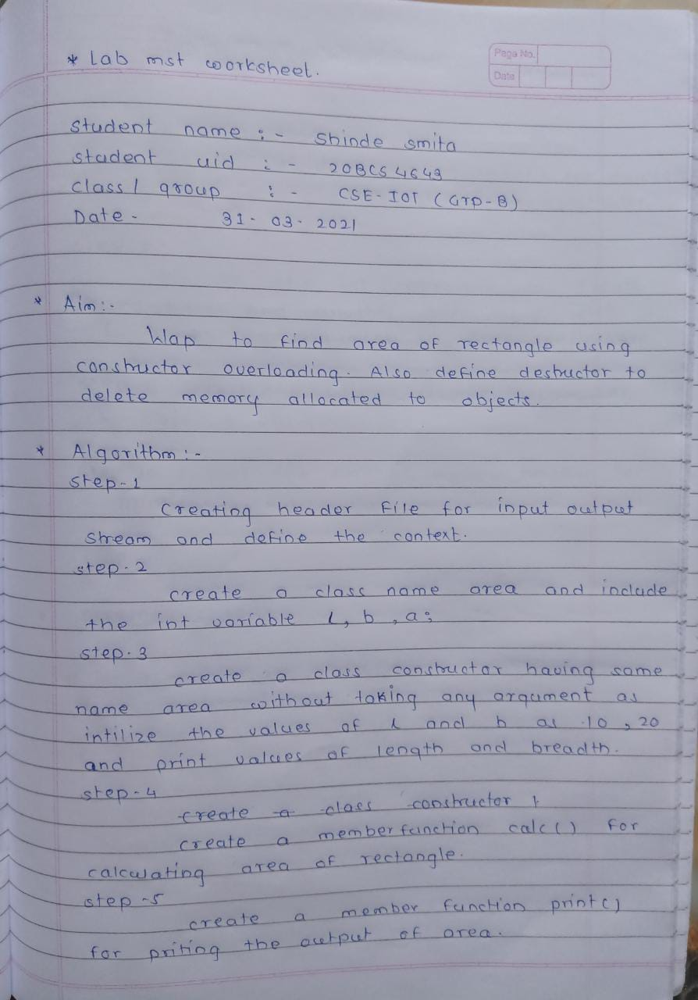

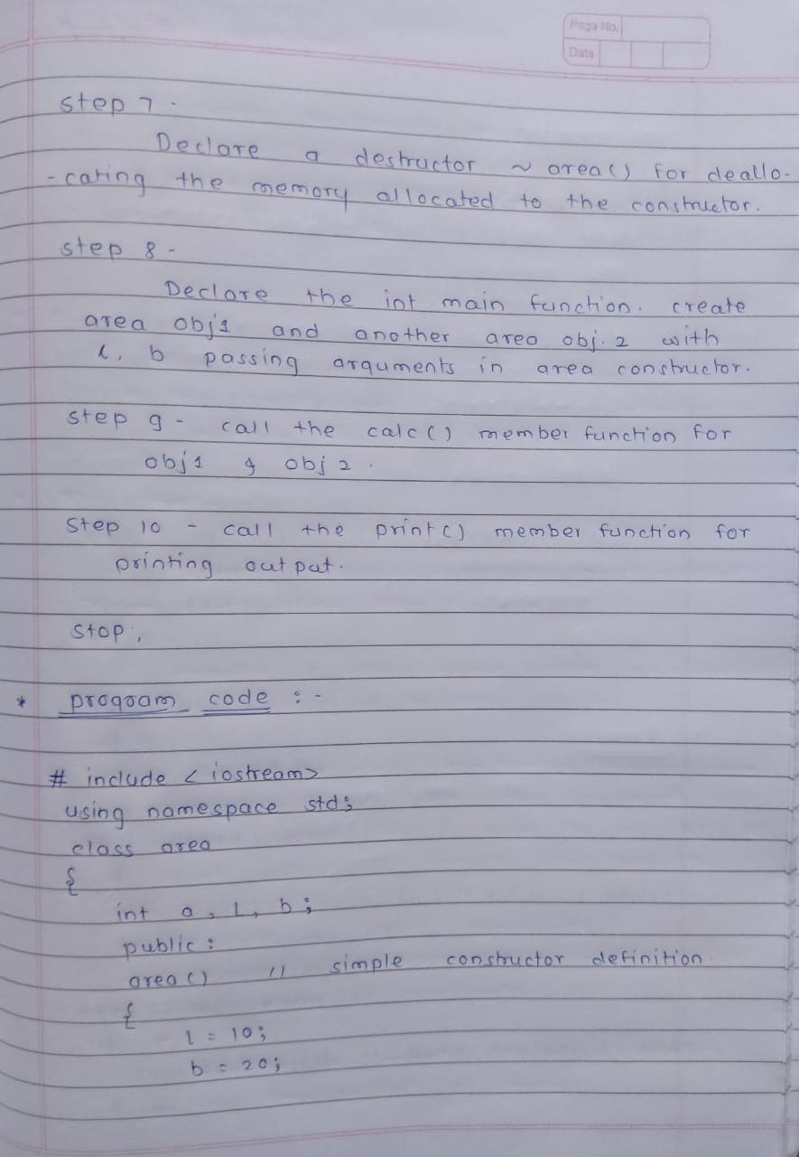

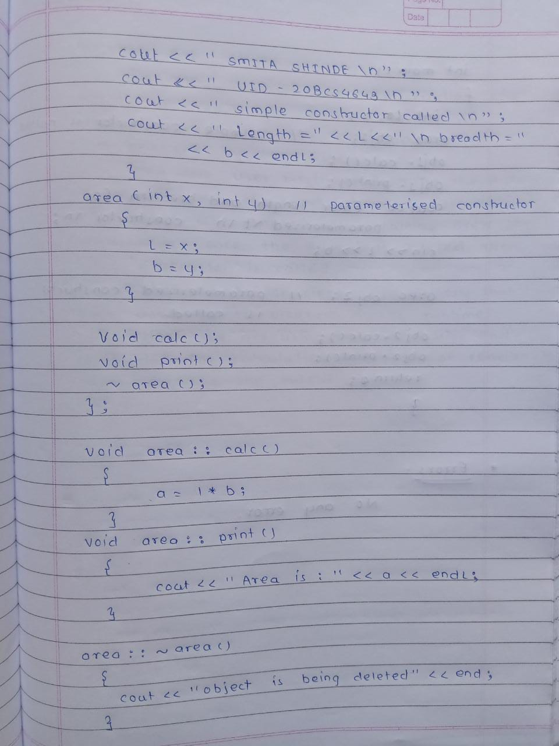

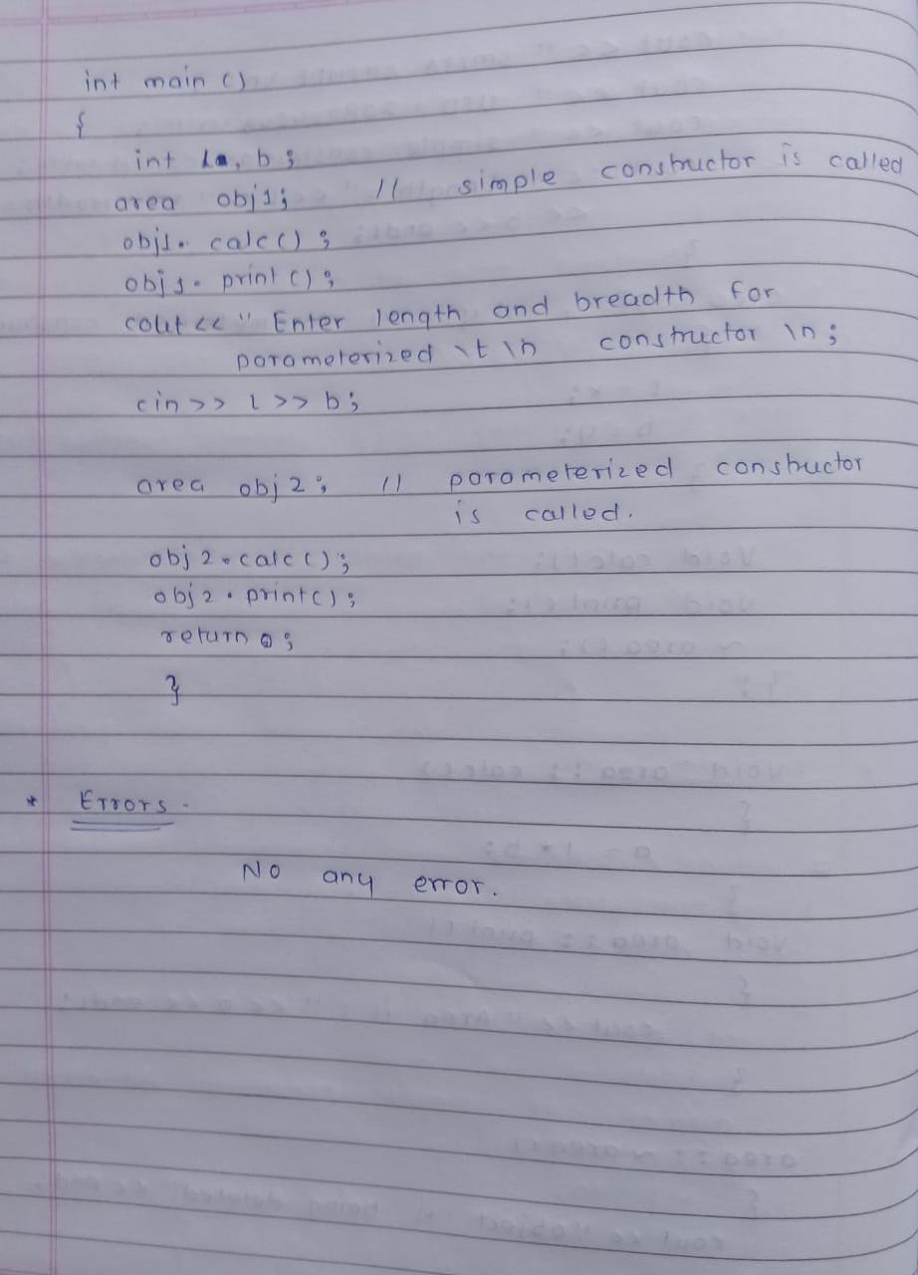

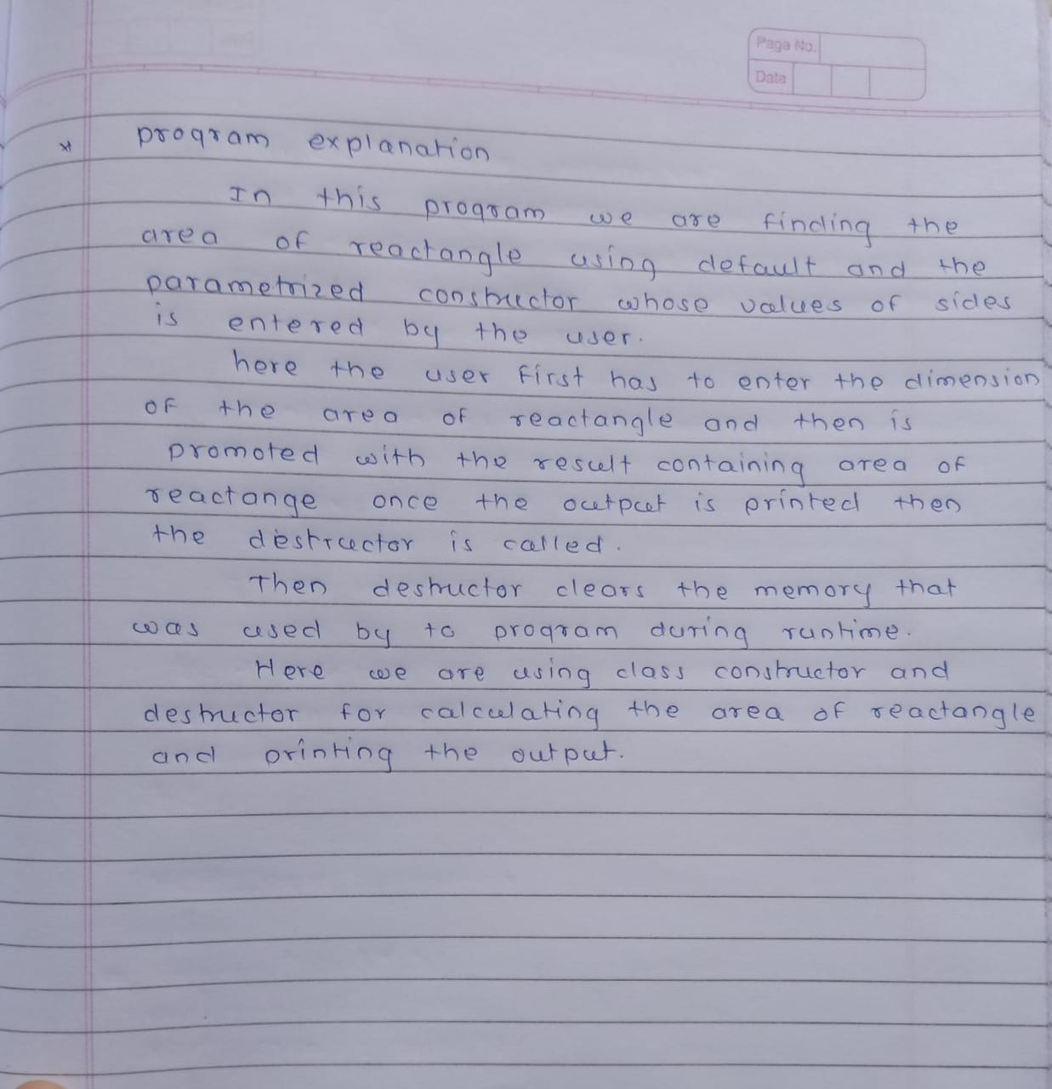

PROGRAM CODE

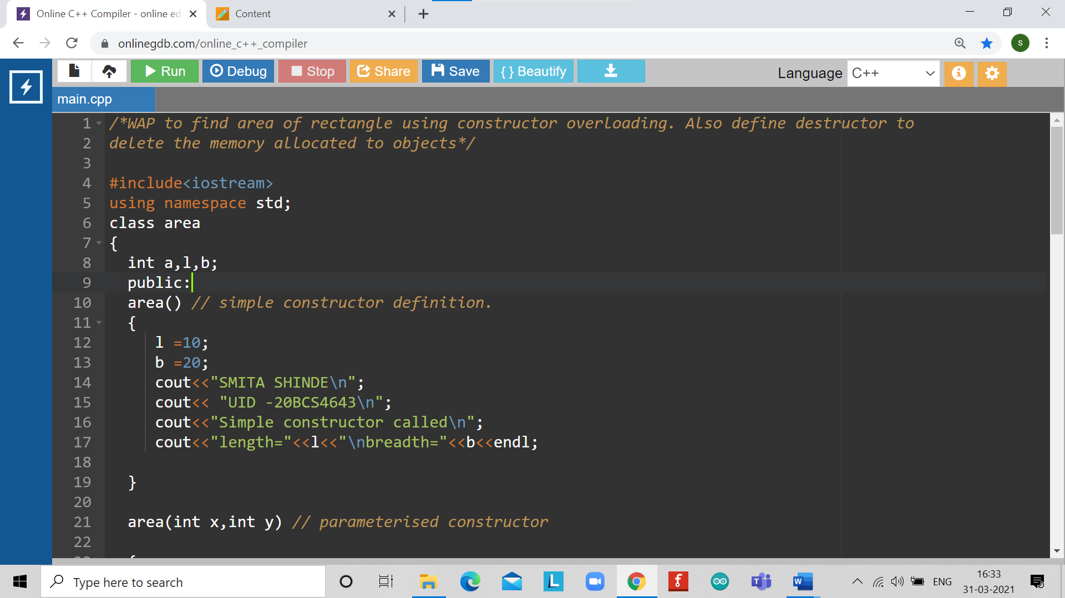

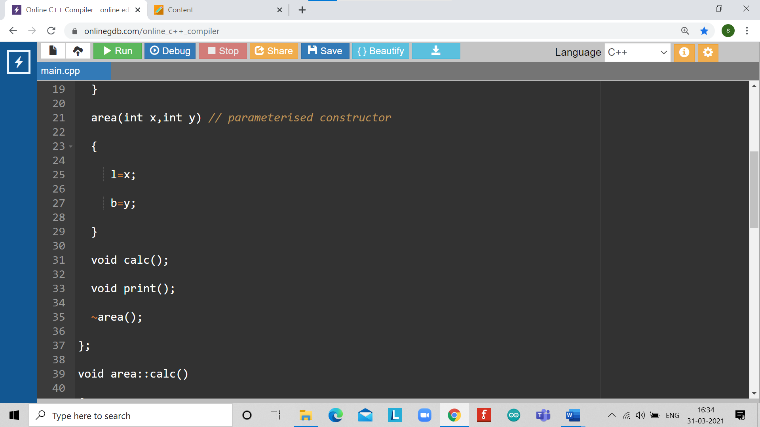

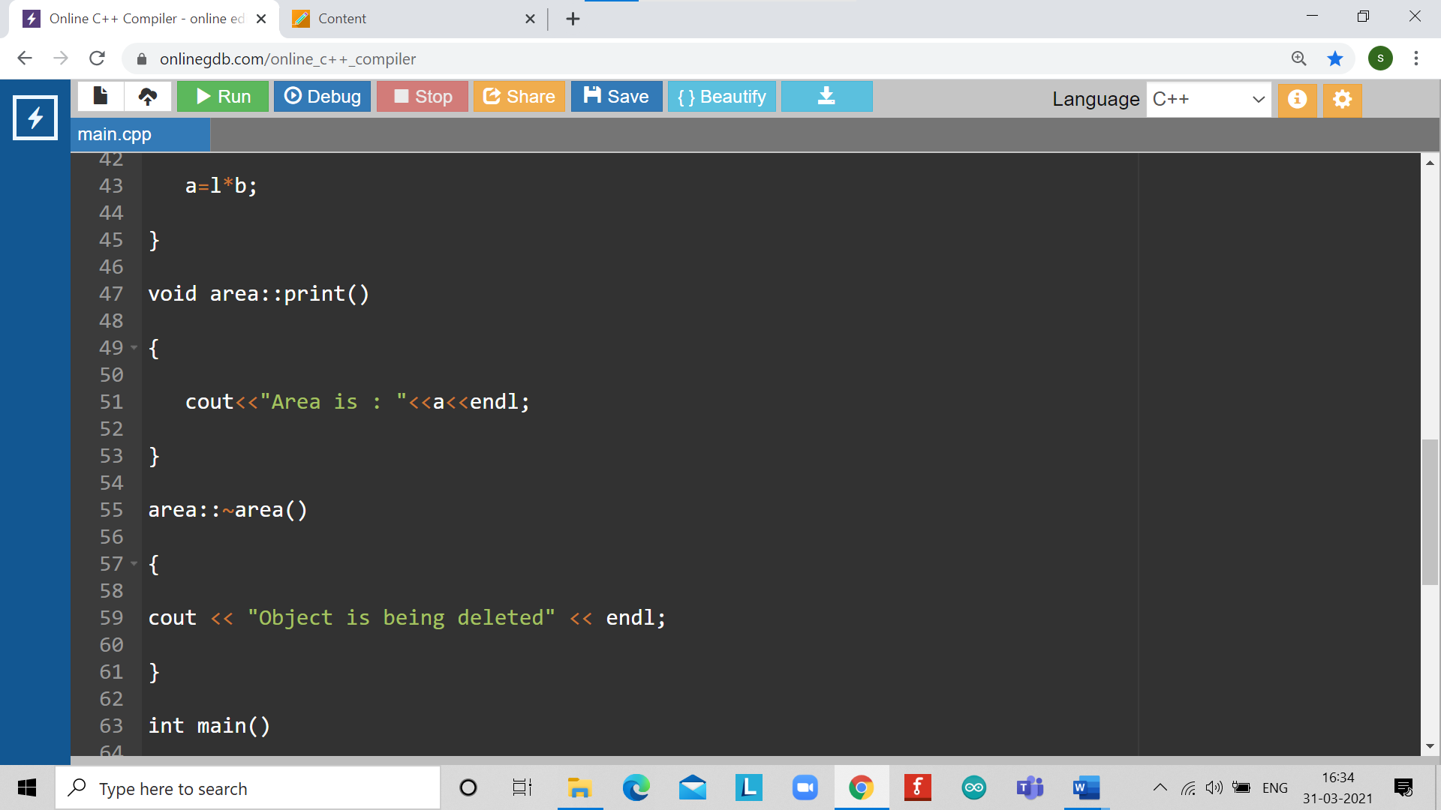

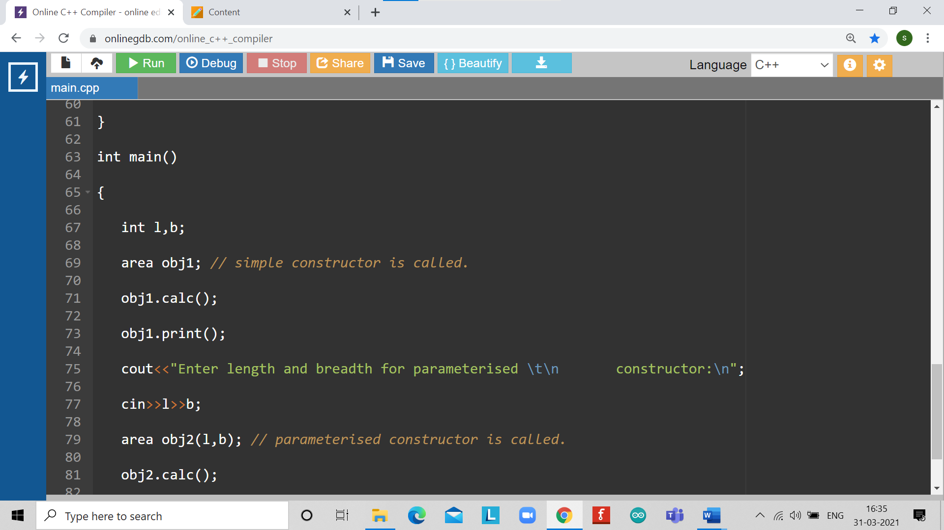

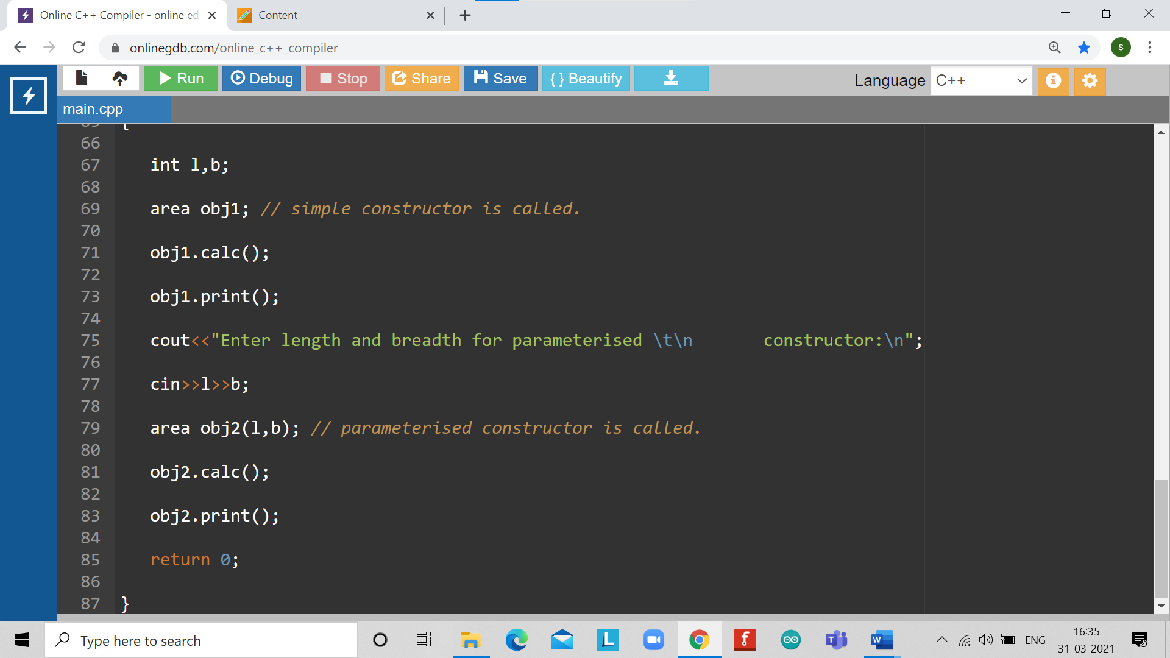

OUTPUT

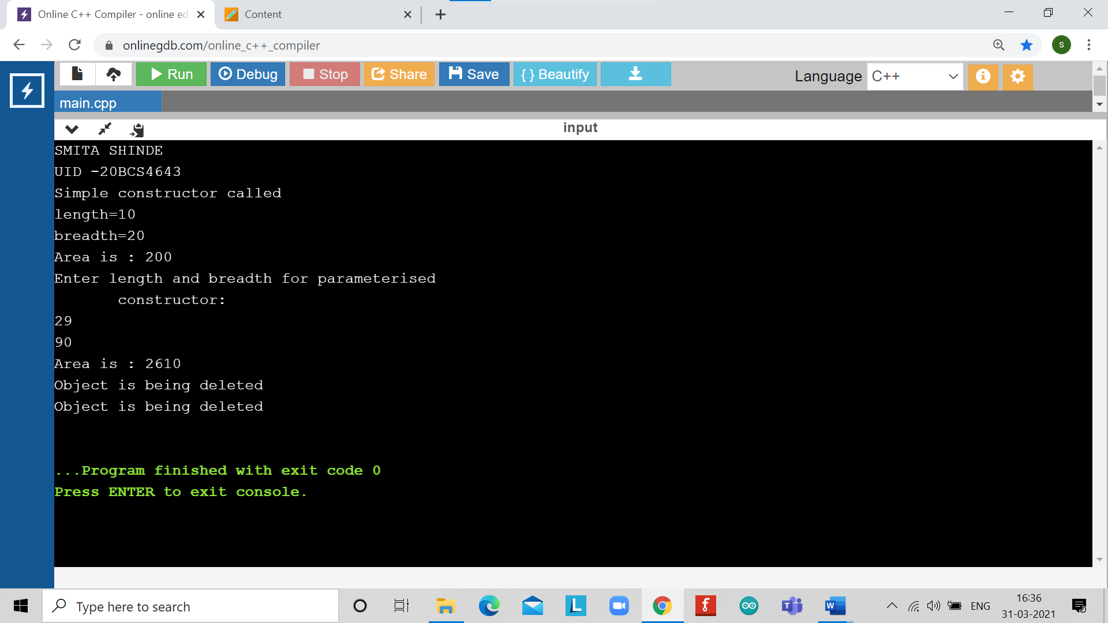

LEARNING OUTCOMES

|  |
| --- |
| * Identify situations where computational methods would be useful. |
| * Approach the programming tasks using techniques learnt and write pseudo-code. |
| * Choose the right data representation formats based on the requirements of the problem. |
| * Use the comparisons and limitations of the various programming constructs and choose the right one for the task. |

EVALUATION COLUMN (To be filled by concerned faculty only)

|  |  |  |  |
| --- | --- | --- | --- |
| **Sr. No.** | **Parameters** | **Maximum**  **Marks** | **Marks**  **Obtained** |
| 1. | Worksheet Completion including writing learning objective/ Outcome | 10 |  |
| 2. | Post Lab Quiz Result | 5 |  |
| 3. | Student engagement in Simulation/ Performance/ Pre Lab Questions | 5 |  |
| 4. | Total Marks | 20 |  |